IMPLEMENTATION PLAN FOR B.SC (HONS) DEGREE PROGRAM
OF HUMAN NUTRITION DEPARTMENT

AT Findings | Corrective Action | Implementation Date | Responsible Body | Resources Needed
Criterion 1:  All Ten proformae are not used for evaluation. | Evaluation through all ten proformae where applicable should be done periodically. | From next semester onward. | Chairman HN and Program Team members. | All ten Proformae
Criteria 3:  (Laboratory and Computing Facility)  No computer lab available in the department. Provision of computers and IT facilities | Project proposal should be submitted for establishment of computer lab. | 2013 | Chairman HN | Funds for establishment of advance computers and IT facilities.
Criteria 7:  (Institutional Facilities)  Space problem; class rooms are insufficient for undergraduate students. | Directorate of Teaching should be contacted for provision of required number of classrooms. | As soon as possible | Chairman HN/ Director Teaching | Space and Well-equipped classrooms.
Criteria 3:  (Laboratory and Computing Facility)  Lack of support personnel for labs. | Existing staff should be trained and if possible hire technical person for lab. | 2012-2013 | Human Nutrition / Registrar | Resource person/HR.
Criteria 6  Faculty:  High qualified Faculty recruitment is needed. | Hiring of high qualified staff. | 2013 | Chairman HN/ Registrar | Human Resource
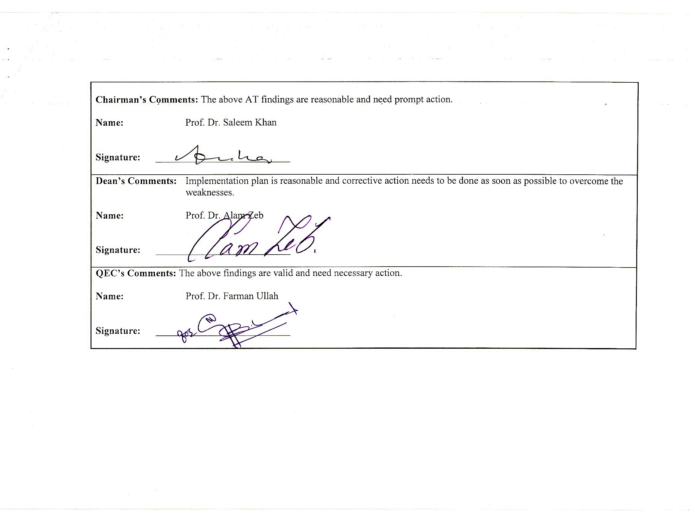
Chairman’s Comments: The above AT findings are reasonable and need prompt action.

Name: Prof. Dr. Saleem Khan

Signature: ___________________________

Dean’s Comments: Implementation plan is reasonable and corrective action needs to be done as soon as possible to overcome the weaknesses.

Name: Prof. Dr. Alam Zeb

Signature: ___________________________

QEC’s Comments: The above findings are valid and need necessary action.

Name: Prof. Dr. Farman Ullah

Signature: ___________________________

